Airline Reservation System

Introduction

Project Overview:

Airline Reservation System contains the details about flight schedules and its fare tariffs, passenger reservations and ticket records. Air Alliance operates flights to different destination in Nepal namely Pokhara, Biratnagar.

Project Description:

Airline Reservation System will hold flight schedules and its fare tariffs, passenger reservations and ticket records. It saves time as it allows online procedure as users no longer to wait in a queue to book the flights. It is automatically generated by the server. Admin is the main authority who can do addition, deletion, and modification of flights if required. The Airline Reservation System project is an implementation of a general Airline Ticketing website which helps the customers to search the availability and prices of various airline tickets, along with the different packages available with the reservations. This project also covers various features like online registration of the users, modifying the details of the website by the management staff or administrator of the website, by adding, deleting or modifying the customer details, flights or packages information.

Definitions, Acronyms, and Abbreviations:

* Personal Details: Details of passengers such as user id, phone number, address, passport no, e-mail address etc.
* Contact Details: Details of contact associated with the passenger
* SRS: System Requirement Specification
* WWW: World Wide Web
* MySQL: is a RDBMS based on SQL which is used for adding, removing, and modifying information in the database.
* RDBMS: Relational Database Management System
* HTML: Hypertext Markup Language
* PHP: Hypertext Preprocessor
* CSS: Cascading Style Sheet
* HTTP: Hypertext Transfer Protocol

Problem statement

2.1. Existing System:

* Downloading the ticket form as paper document, filling it manually and submitting it at Airport.
* Fill the Ticket form on system and get the print out as paper documents to submit it at Airport.
* Booking the Ticket at some particular registered ticket counters in online.
* Even above approaches make a ticket booking online, it was not completely done on online. Passenger may not have much freedom over this approach.

Hence the Passenger may or may not be satisfied with this approach as it includes manual intervention like travelling to Airport for booking his ticket.

* Cannot Upload and Download the latest updates.
* No use of Web Services and Remoting.
* Risk of mismanagement and of data when the project is under development.
* Less Security.
* No proper coordination between different Applications and Users.
* Fewer Users – Friendly

Product Functions:

The website will allow access only to authorized users with specific roles

(Administrator- maintains the website, Company-Register the passengers, Passenger- Fills the details).

Passenger role: On the register form, passenger should enter all their detail such as their name, passport number, Email and contact number.

User Characteristics:

End Users:

All specific knowledge or skills are required from the feeder.

Educational level: Users should be comfortable with the English language.

Experience: Users should have prior information regarding the online booking.

Skills: Users should have basic knowledge and should be comfortable

Administrator:

* Administrator must be capable to manage user rights.
* This system will not take care of any virus problem, which might occur either on the Client or the server system.

Objectives:

* To ensure the complete freedom for users, where user at his own system can log on to this website and can book his ticket. This proposed system allows only registered users to book the tickets, view timings and cancel their tickets.
* To build strong password mechanism.

3.1. Requirement identification:

Study of existing system:

* User login
* Update
* Add
* Delete

Requirement collection:

* User information
* Data analysis
* Data review
* Id/proof

**Feasibility study**:

Technical feasibility:

The technical issue usually raised during the feasibility stage of the investigation includes the following:

* Does the necessary technology exist to do what is suggested?
* Does the proposed equipment have the technical capacity to hold the data required to use the new system?
* Will the proposed system provide adequate response to inquiries, regardless of the number or location of users?
* Can the system be upgraded if developed?
* Are there technical guarantees of accuracy, reliability, ease of access and data security?

Earlier no system existed to cater to the needs of ‘Secure Infrastructure Implementation System’ the current system developed is technically feasible. It is a web based user interface for audit workflow. Thus, it provides an easy access to the users.

Operational Feasibility:

Proposed projects are beneficial only if they can be turned out into information system. That will meet the organization’s operating requirements. Operational feasibility aspects of the project are to be taken as an important part of the project implementation. Some of the important issues raised are to test the operational feasibility of a project includes the following:

* Is there sufficient support for the management from the users?
* Will the system be used and work properly if it is being developed and implemented?
* Will there be any resistance from the user that will undermine the possible application benefits?

This system is targeted to be in accordance with the above-mentioned issues. Beforehand, the management issues and user requirements have been taken into consideration. So, there is no question of resistance from the users that can undermine the possible application benefits.

Economic Feasibility:

A system can be developed technically and that will be used if installed must still be a good investment for the organization. In the economic feasibility, the development cost in creating the system is evaluated against the ultimate benefit derived from the new systems. Financial benefits must equal or exceed the costs.

Case diagram

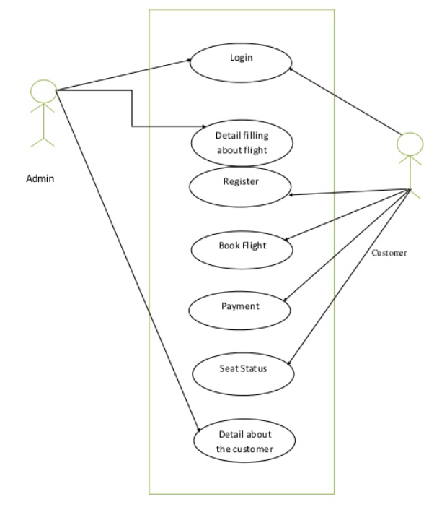

Software development lifecycle

SDLC is a process followed for a software project, within a software organization. It consists of a detailed plan describing how to develop, maintain, replace and alter or enhance specific software. The life cycle defines a methodology for improving the quality of software and the overall development process.

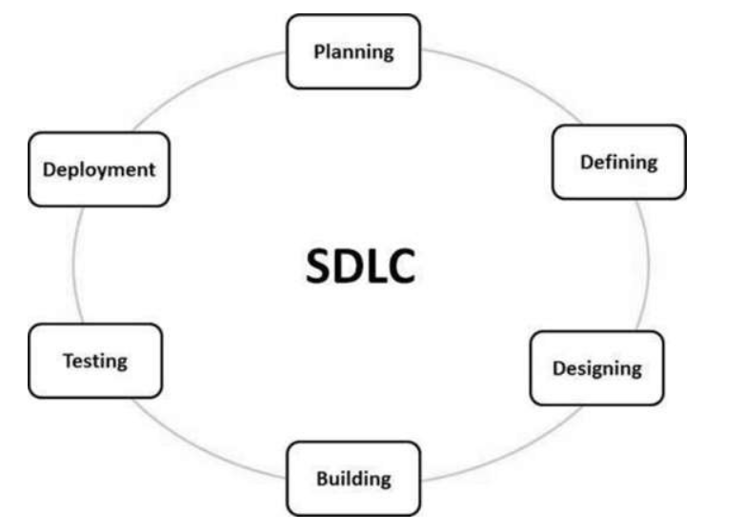

* Planning and requirement analysis:

Planning for the quality assurance requirements and identification of the risks associated with the project is done in the planning stage. The outcome of the technical feasibility study is to define the various technical approaches that can be followed to implement the project successfully with minimum risks.

* Defining Requirements

After requirement analysis is done the next step is to clearly define and document the product requirements and get them approved from the customer or the market analysts. This is done through an SRS (Software Requirement Specification) document which consists of all the product requirements to be designed and developed during the project life cycle.

### Designing:

### A design approach clearly defines all the architectural modules of the product along with its communication and data flow representation with the external and third party modules (if any).

### Building or Developing the Product:

### In this stage of SDLC the actual development starts and the product is built. The programming code is generated as per design document specification during this stage.

### Testing:

### This stage refers to the testing only stage of the product where product defects are reported, tracked, fixed and retested, until the product reaches the quality standards defined in the SRS.

### Deployment in the Market and Maintenance

### Once the product is tested and ready to be deployed it is released formally in the appropriate market.  After the product is released in the market, its maintenance is done for the existing customer base

**Tools and technology**

Tools

* PHP,MYQL -used to develop web application
* Xammp -used for testing sutie
* Visual studio Code -used for text editor for code
* Html –used to design user interface

Time Schedule and Project Task

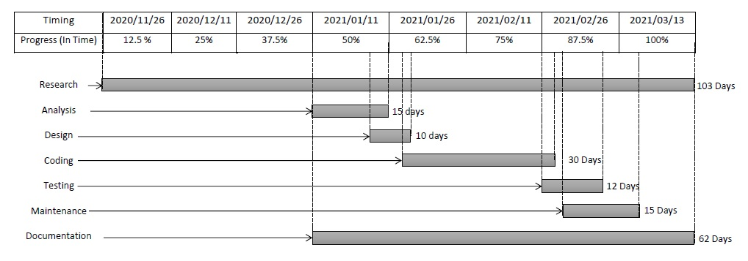

Reference:

* BCA 4TH SEM project class